**Time Series Analysis of pm2.5 particles in Daily Pollution Data**

**From 2012-2014 in “Queens NY”**

**We used “xts” package and ts function from base R for the Time Series analysis**

**Trend**

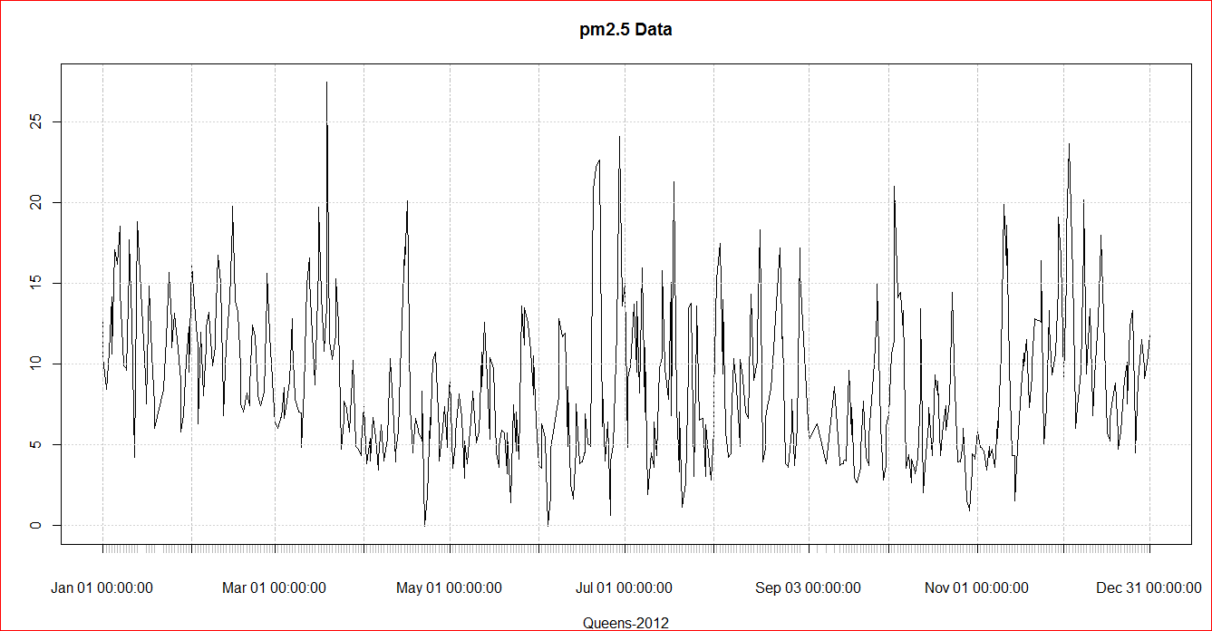

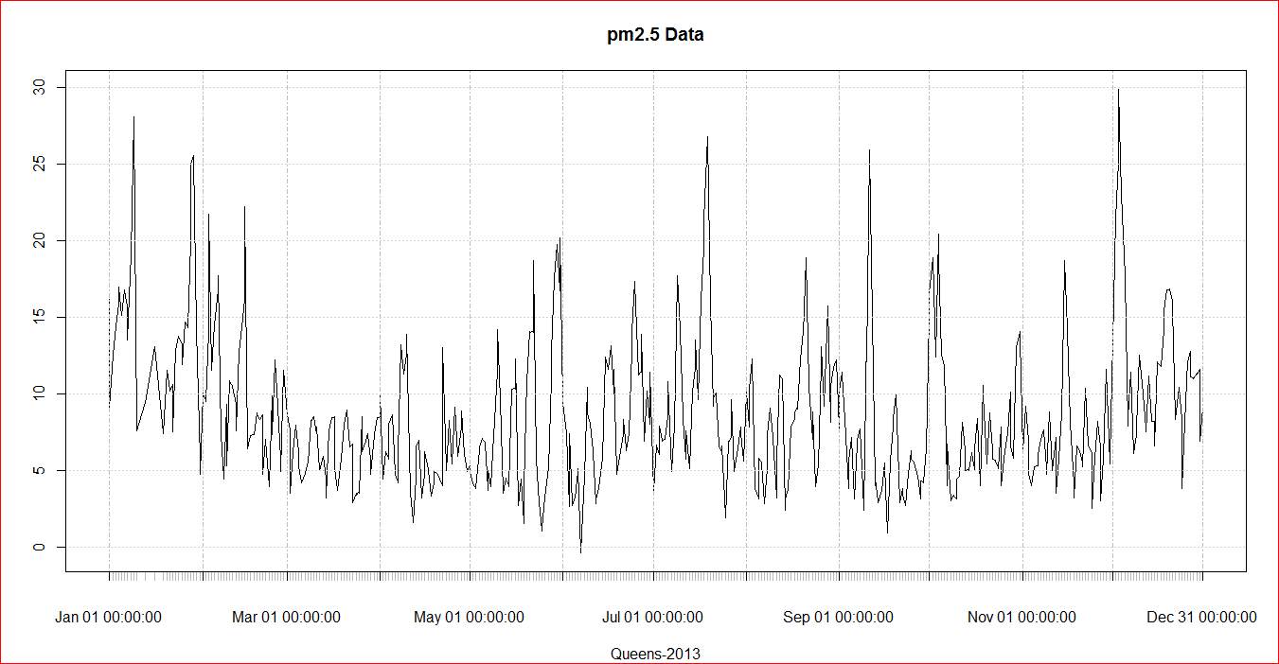

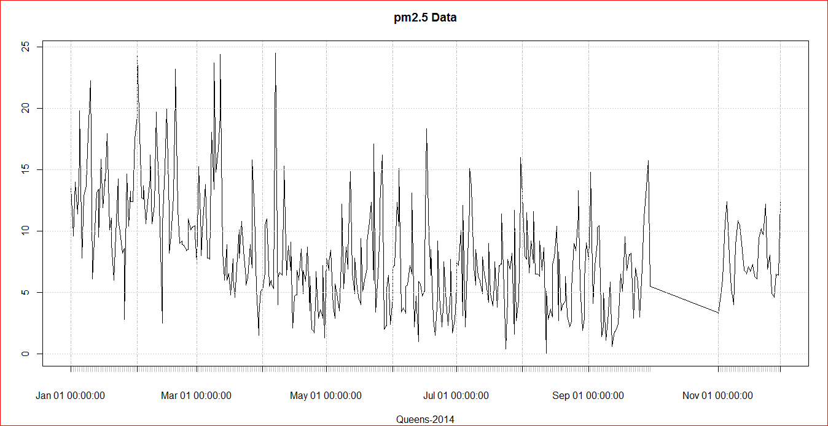

**Decomposing Seasonal Data**

To estimate the trend component and seasonal component of a seasonal time series that can be described using an additive model, we can use the “**decompose()”** function in R. This function estimates the trend, seasonal, and irregular components of a time series that can be described using an additive model.

The function “decompose()” returns a list object as its result, where the estimates of the seasonal component, trend component and irregular component are stored in named elements of that list objects, called “seasonal”, “trend”, and “random” respectively.

**used Daily pm2.5 Pollution data from 2011 to 2014**

